System and Software Architecture Description (SSAD)

Improvement on VITA website

Team #8

Team members | Primary Role | Secondary Role
Youn Kyu Lee | Project Manager | Life Cycle Planner, Web Designer
Melissa Roemmele | Operational Concept Engineer | Requirements Engineer,  Web Designer
JungYoun Ku | Requirement Engineer | Feasibility Analyst
Jeonghoon Yun | Prototyper, Builder | Software Architect, Trainer
Woochan Jun | Software Architect | Prototyper, Builder
Hiram Garcia | IIV&V | Shaper, Tester

11/20/2012

Version History
Date | Author | Version | Changes made | Rationale
10/15/12 | Woochan Jun, Jeonghoon Yun | 1.0 | - Original SSAD template | - Initial version of the SSAD, ver 1.0
10/21/12 | Woochan Jun, Jeonghoon Yun | 1.1 | - Document format has been changed from Architected Agile to NDI_NCS, Section 1 and 2 have been completed. | - To fulfill exit conditions of Draft FC package
10/24/12 | Woochan Jun | 1.2 | - Some confused words has been changed. (Login to Log-in, Logout to Log-out, and ID to username) | - To meet on response to Evaluation of Core FC Package
10/28/12 | Woochan Jun, Jeonghoon Yun | 1.3 | - Status of SSAD has been updated  - Artifacts and Information Diagram has been changed.  - Use-case diagram has been changed  - Behavior section has been updated | - To meet on consistency with PRO.  - System architecture has been changed in the client meeting  - To prune inappropriate use-cases  - System functions has been reorganized
11/06/12 | Woochan Jun, Jeonghoon Yun, Ku | 2.0 | - System context diagram has been changed  - Status of SSAD has been updated  - Artifacts and Information Diagram has been modified.  - Use-case diagram has been modified  - Behavior section has been updated  - NDI/NCS interoperability analysis has been updated. | - To meet on consistency with PRO  - To meet on the project milestone, which has been changed from two semester to one semester  - To fulfill exit condition of DC package
11/20/12 | Woochan Jun, Jeonghoon Yun | 2.1 | - All figures has been changed (context diagram, artifacts and information diagram, and use case diagram)  - As use-case diagram has been changed, list of use case and description of it has been modified.. | - To meet on TA’s feedback

Table of Contents
System and Software Architecture Description (SSAD) i
Version History ii
Table of Contents iii
Table of Tables iv
Table of Figures v
1. Introduction 1
1.1 Purpose of the SSAD 1
1.2 Status of the SSAD 1
2. System Analysis 2
2.1 System Analysis Overview 2
3. NDI/NCS Interoperability Analysis 13
3.1 Introduction 13
3.2 System Structure 14
3.3 Evaluation Summary 15

Table of Tables
Table 1: Actors Summary 3
Table 2: Artifacts and Information Summary 4
Table 3: Process Description (Make new client appointment) 6
Table 4: Typical Course of Action (Make new client appointment): Successful 6
Table 5: Alternative Course of Action (Make new client appointment): Failure 6
Table 6: Process Description (Make new volunteer appointment) 7
Table 7: Typical Course of Action (Make new volunteer appointment): Successful 7
Table 8: Alternative Course of Action (Make new volunteer appointment): Failure 7
Table 9: Process Description (Cancel volunteer Appointment) 8
Table 10: Typical Course of Action (Cancel volunteer appointment): Successful 8
Table 11: Alternative Course of Action (Cancel volunteer appointment): Failure 8
Table 12: Process Description (Submit Volunteer Application) 9
Table 13: Typical Course of Action (Submit Volunteer Application) 9
Table 14: Typical Course of Action (Submit Volunteer Application) 9
Table 15: Process Description (View Client Schedule) 10
Table 16: Typical Course of Action (View Schedule for Client and Volunteer) 10
Table 17: Process Description (View Volunteer Schedule) 10
Table 18: Typical Course of Action (View Volunteer Schedule) 11
Table 19: Process Description (View Volunteer List) 11
Table 20: Typical Course of Action (View Client and Volunteer List) 11
Table 21: Process Description (View Volunteer Application) 11
Table 22: Typical Course of Action (View Volunteer Application) 12
Table 23: Process Description (Cancel Client Application) 12
Table 24: Typical Course of Action (Cancel Client Application) 12
Table 25: NDI Products Listing 13
Table 26: NDI Evaluation 15

Table of Figures
Figure 1: System Context Diagram 2
Figure 2: Artifacts and Information Diagram 3
Figure 3: Process Diagram 5
Figure 4: System Structure 15

Introduction

Purpose of the SSAD
System and Software Architecture Description (SSAD) provides analysis, design, and architecture of the project. This document is critical in transition from exploration phase to foundation phase by providing architectural design of the proposed system. Later, this document will help not only developers, but also maintainers and client to understand whole structure of the proposed system.

Status of the SSAD
Based on our client’s requirement changes and TA’s feedback, this document has been changed a lot in this version (2.1). Artifacts and information diagram, use-case diagram, and behavior diagram have been changed on this version of document to make consistency with final deliverable. Every process description and course of action has been sorted out, and redundant cases are deleted.

System Analysis

System Analysis Overview

The purpose of the system is providing more efficient ways to schedule volunteers and clients receive application from volunteers, and more professional design of the website; potential clients and volunteers can visit the VITA website which is implemented by WordPress and professional look of the website will intrigue them to work with VITA; volunteers can submit their application through Google Docs; volunteers can schedule their work sessions through VolunteerSpot; clients can submit their contact information and schedule their appointment through Google Docs; the VITA committee who is also website administrator can easily maintain and update the website.

System Context
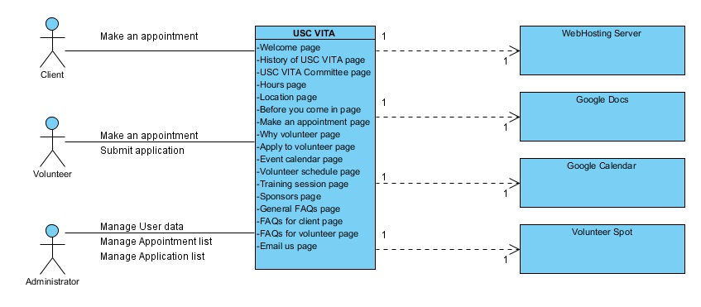
Figure 1: System Context Diagram
Table 1: Actors Summary
Actor | Description | Responsibilities
Client | Client is a user who wants to use USC VITA services. | Make, edit, and cancel appointment
Volunteer | Volunteer is a user who serves USC VITA | Make, edit, and cancel appointment, and make volunteer submission
Administrator | Administrator is a user who manages whole USC VITA website | Manage (add, edit, delete) user list, Approve volunteer application, and manage (add, edit, delete) schedule for both client and volunteer

Artifacts & Information
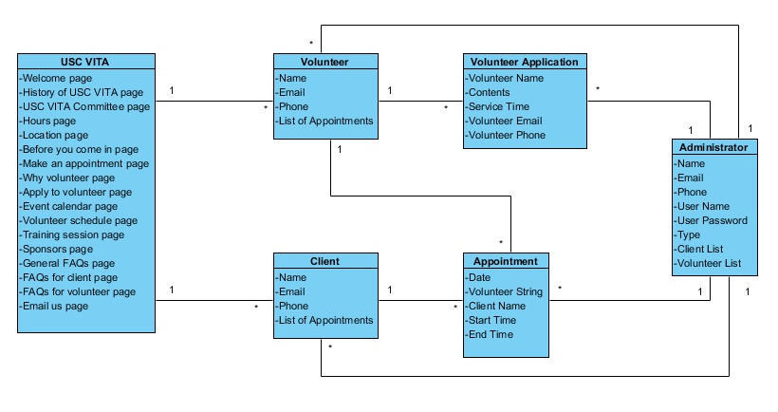
Figure 2: Artifacts and Information Diagram
Table 2: Artifacts and Information Summary
Artifact | Purpose
ATF-1 : USC VITA | USC VITA artifact contains all information about the system including all of system data and user data.  About Us: To briefly introduce about USC VITA in general.  History of USC VITA : To explain USC VITA focusing on its history  USC VITA members: To introduce USC VITA members who are in charge of operation of organization.  Hours: To notice service hours of USC VITA  Location : To give a direction to get USC VITA  Tutorial: Tutorial consists of two separate parts. One of them is for clients and the other one is for volunteers. There separate tutorials are for users’ convenience in using USC VITA website.  Email Us: Website user is able to organize their question then automatically email USC VITA  FAQs: FAQ contains the list of frequently asked questions about USC VITA.
ATF-2 : Clients | To store each client’s information. The client is able to make a new appointment.
ATF-3 : Volunteer | To store each volunteer’s information. The volunteer is able to make and cancel an appointment and can submit volunteer applications.
ATF-4 : Administrator | To store administrator’s information then distinguish this user from other normal user. The administrator is able to see a list of all clients and volunteers, all appointments, and all volunteer submissions. Administrator also can modify the above artifacts.
ATF-5 : Volunteer Application | To contain the information regarding volunteers who submitted application.
ATF-6 : Appointment | To contain the information regarding appointment submitted by client and volunteer.

Behavior
Below Use-Case Diagram shows the process between actors and VITA website.

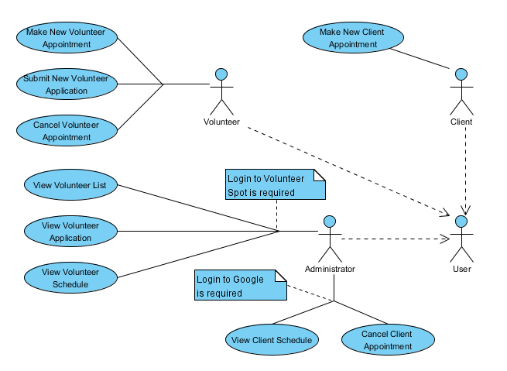
Figure 3: Process Diagram

Client Service

Schedule Client Appointment
Table 3: Process Description (Make new client appointment)
Identifier | UC-1: Make new client appointment
Purpose | Make an appointment for client
Requirements | WC_1504, WC_1258, WC_1256, WC_1254, WC_1247 WC_1239, WC_1242, WC_1253, WC_1258, WC_1475, WC_1476
Development Risks | None(this is 100% NDI project)
Pre-conditions | Client is in “Make an appointment” page in order to make an appointment.
Post-conditions | New appointment is arranged or not.

Table 4: Typical Course of Action (Make new client appointment): Successful
Seq# | Actor’s Action | System’s Response
1 | Enter required information for making an appointment
2 | Click submit button
3 |  | Check all required information has been filled out
4 |  | Show new appointment to client

Table 5: Alternative Course of Action (Make new client appointment): Failure
Seq# | Actor’s Action | System’s Response
1 | Enter required information for making an appointment
2 | Click submit button
3 |  | Redirect to “Make an appointment” page

Volunteer Service

Make New Volunteer Appointment
Table 6: Process Description (Make new volunteer appointment)
Identifier | UC-2: Make new volunteer appointment
Purpose | Make new appointment for volunteer
Requirements | WC_1255, WC_1245, WC_1247, WC_1239, WC_1242, WC_1253, WC_1258, WC_1475, WC_1476
Development Risks | None(this is 100% NDI project)
Pre-conditions | Volunteer is in “Volunteer Schedule” page in order to make an appointment.
Post-conditions | New appointment is arranged or not.

Table 7: Typical Course of Action (Make new volunteer appointment): Successful
Seq# | Actor’s Action | System’s Response
1 | Choose one of available time slots and then fill out his/her information on the form
2 | Click submit button
3 |  | Check chosen time slot is available
4 |  | Show new appointment to client

Table 8: Alternative Course of Action (Make new volunteer appointment): Failure
Seq# | Actor’s Action | System’s Response
1 | Choose one of available time slots and then fill out his/her information on the form
2 | Click submit button
3 |  | Check chosen time slot is available
4 |  | Return to scheduling page

Cancel Volunteer Appointment
Table 9: Process Description (Cancel volunteer Appointment)
Identifier | UC-3: Cancel Volunteer Appointment
Purpose | Cancel scheduled appointment for volunteer
Requirements | WC_1504, WC_1258, WC_1256, WC_1254, WC_1247, WC_1239, WC_1242, WC_1253, WC_1258, WC_1475, WC_1476
Development Risks | None(this is 100% NDI project)
Pre-conditions | Volunteer is in “Volunteer Schedule” page in order to cancel an appointment.
Post-conditions | Existing appointment is canceled or not.

Table 10: Typical Course of Action (Cancel volunteer appointment): Successful
Seq# | Actor’s Action | System’s Response
1 | Choose one of existing appointments
2 | Click cancel button
3 |  | Remove chosen appointment
4 |  | Ask to user to confirm canceling an appointment
5 |  | Remove chosen appointment from the schedule.

Table 11: Alternative Course of Action (Cancel volunteer appointment): Failure
Seq# | Actor’s Action | System’s Response
1 | Choose one of existing appointments
2 | Click cancel button
3 |  | Remove chosen appointment
4 |  | Ask to user to confirm canceling an appointment
5 |  | Redirect to “Volunteer Schedule” page.

Submit Volunteer Application
Table 12: Process Description (Submit Volunteer Application)
Identifier | UC-4: Submit New Application
Purpose | Make a new submission to be a volunteer
Requirements | WC_1511, WC_1489, WC_1469, WC_1252, WC_1247, WC_1239, WC_1242, WC_1253, WC_1258, WC_1475, WC_1476
Development Risks | None(this is 100% NDI project)
Pre-conditions | Prospective volunteer is in “Apply to Volunteer” page.
Post-conditions | New volunteer submission is submitted or not

Table 13: Typical Course of Action (Submit Volunteer Application)
Seq# | Actor’s Action | System’s Response
1 | Fill out required information for volunteer submission
2 | Click submit button
3 |  | Check all required information has been filled out
4 |  | Show complete message to client

Table 14: Typical Course of Action (Submit Volunteer Application)
Seq# | Actor’s Action | System’s Response
1 | Fill out required information for volunteer submission
2 | Click submit button
3 |  | Check all required information has been filled out
4 |  | Redirect to “Apply to Volunteer” page

Administrator Service

View Client Schedule
Table 15: Process Description (View Client Schedule)
Identifier | UC-5: View Client Schedule
Purpose | Show whole schedule for client
Requirements | WC_1255, WC_1245, WC_1511, WC_1489, WC_1469, WC_1252, WC_1247, WC_1239, WC_1242, WC_1253, WC_1258, WC_1475, WC_1476
Development Risks | None(this is 100% NDI project)
Pre-conditions | Administrator is in Google Drive – My document page.
Post-conditions | Nothing is changed

Table 16: Typical Course of Action (View Schedule for Client and Volunteer)
Seq# | Actor’s Action | System’s Response
1 | Click client appointment spreadsheet
2 |  | Show whole client schedule

View Volunteer Schedule
Table 17: Process Description (View Volunteer Schedule)
Identifier | UC-6: View Volunteer Schedule
Purpose | Show whole schedule for volunteer
Requirements | WC_1255, WC_1245, WC_1511, WC_1489, WC_1469, WC_1252, WC_1247, WC_1239, WC_1242, WC_1253, WC_1258, WC_1475, WC_1476
Development Risks | None(this is 100% NDI project)
Pre-conditions | Administrator is in Volunteer Spot – My activity page.
Post-conditions | Nothing is changed

Table 18: Typical Course of Action (View Volunteer Schedule)
Seq# | Actor’s Action | System’s Response
1 | Click volunteer appointment activity
2 |  | Show whole volunteer schedule

View Volunteer List
Table 19: Process Description (View Volunteer List)
Identifier | UC-7: View Volunteer List
Purpose | Show a list of volunteer
Requirements | WC_1511, WC_1489, WC_1469, WC_1252, WC_1247, WC_1239, WC_1242, WC_1253, WC_1258, WC_1475, WC_1476
Development Risks | None(this is 100% NDI project)
Pre-conditions | Administrator is in Volunteer Spot – My activity – View volunteer page.
Post-conditions | Nothing is changed

Table 20: Typical Course of Action (View Client and Volunteer List)
Seq# | Actor’s Action | System’s Response
1 | Click volunteer appointment activity
2 |  | Show whole volunteer schedule

View Volunteer Application
Table 21: Process Description (View Volunteer Application)
Identifier | UC-8: View Volunteer Application
Purpose | See whole volunteer application
Requirements | WC_1504, WC_1258, WC_1256, WC_1254, WC_1511, WC_1489, WC_1469, WC_1252, WC_1247, WC_1239, WC_1242, WC_1253, WC_1258, WC_1475, WC_1476
Development Risks | None(this is 100% NDI project)
Pre-conditions | Administrator is in Google Drive – My document page.
Post-conditions | Nothing is changed

Table 22: Typical Course of Action (View Volunteer Application)
Seq# | Actor’s Action | System’s Response
1 | Click volunteer submission spreadsheet
2 |  | Show whole volunteers

Cancel Client Appointment
Table 23: Process Description (Cancel Client Application)
Identifier | UC-9: Cancel Client Appointment
Purpose | Cancel existing client appointment
Requirements | WC_1504, WC_1258, WC_1256, WC_1254, WC_1247, WC_1239, WC_1242, WC_1253, WC_1258, WC_1475, WC_1476
Development Risks | None(this is 100% NDI project)
Pre-conditions | Administrator received email regarding appointment cancel from client, so he/she is in Google Drive – My document page in order to do client’s request.
Post-conditions | Existing client appointment is canceled.

Table 24: Typical Course of Action (Cancel Client Application)
Seq# | Actor’s Action | System’s Response
1 | Drag column containing certain client’s schedule, and then press delete button
2 |  | Reflect changes to spreadsheet (Existing appointment is deleted in the document)

NDI/NCS Interoperability Analysis

Introduction
There are several NCS using for this project, such as Google Calendar, Google Docs, Volunteerspot, and WordPress.

COTS / GOTS / ROTS / Open Source / NCS
Table 25: NDI Products Listing
NDI/NCS Products | Purposes
Google Calendar | To show USC VITA schedules
Google Docs | To submit volunteer applications
Volunteerspot | To schedule volunteer appointment
WordPress | To provide professional design and easy maintenance of the website to USC VITA committee

Connectors
- In this project, we embedded Google Calendar and Google Maps on the WordPress webpage for connection.
- In this project, we use a hyperlink on the menu to get connected Google Docs and Volunteer Spot.

Legacy System
All services in this project don’t have to be compatible with WordPress. It will be preferable if they are working with WordPress, but we can use a hyperlink to connect them instead of embedding.

System Structure
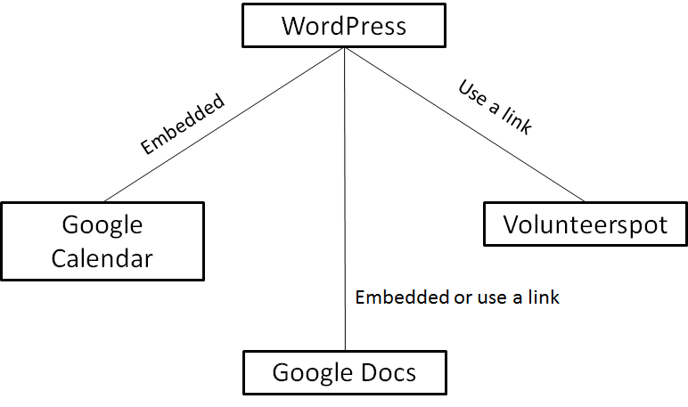
Figure 4: System Structure

Evaluation Summary
Table 26: NDI Evaluation
NDI | Usages | Comments
Google Calendar | Showing VITA schedules | Widely used NCS is free for using. Also, it provides necessary features and allows users to customize or embed it everywhere they want.
Google Docs | Volunteer application and Client scheduling | Widely used NCS is free for using. Also, it collects data and sorts them into a file which users can see result conveniently.
Volunteerspot | Volunteer scheduling | User friendly interface and no need for login or signup enable users easily access to schedule their working sessions. In addition, it shows available spots in schedule which the client wants.
WordPress | Content Management System | User friendly interface allows users use and maintain their website easily. Since it is free for use, using WordPress is the best option for a non-profit organization. Besides, the client is currently using WordPress; the team doesn’t have to prepare for transition.

